1. Data to be uploaded from backend are as follows. All of these data s should be shown on the frontend and as well as on the backend in the form of tables
2. Drug information- Category- Brand, Generic, Indication, Manufacturer. Search is based on them.
3. Ad posting-(New module already been done)
4. Job posting
5. Pharma News
6. Special Report
7. Doctor information with Search Option on the Doctor’s page
8. Video upload
9. Other Important Information as updated on the frontend. Also on the inner pages of the Important Information Search Option as it is there should be present.
10. Journal under category of Dental, Cardiovascular etc as we have the sub menu on the frontend)
11. Herbal Drug
12. Real time update on these numbers

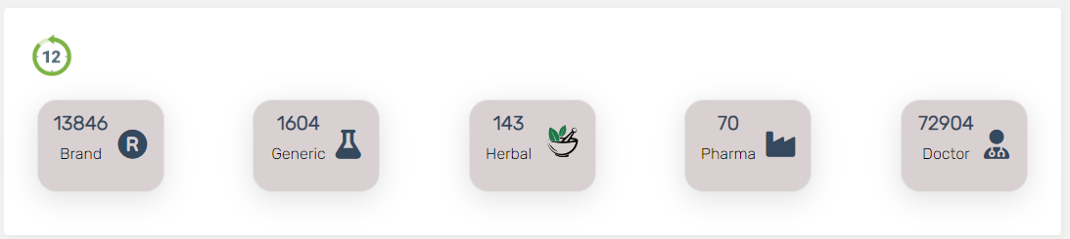

1. Loading time of this site should be managed. The site should perform as generally other information websites work. <https://medex.com.bd/>. You can see this reference site for your perusal.
2. All the data uploaded should be coming on the backend and on the frontend immediately
3. All data should have Add, edit and delete option. And under edit option only one field can also be edited.
4. You can remove login and registration from the frontend as of now.